Table of Contents
1.Overview
  - About Us...................................................................................................
1.2 What is Arduino.....................................................................................................
1.3 What is Mixly.........................................................................................................
1.4 Overview of Bearbot Coding Kit.......................................................................................
2.Introduction to Electronic Hardware
2.1 COKOINO UNO R3 Board ....................................................................................
2.2 COKOINO Motor Drive Shield...................................................................
2.3 COKOINO Ultrasonic Sensor.....................................................................................
2.4 COKOINO IIC 1602LCD Display ..........................................................................
2.5 COKOINO HC-06 Bluetooth Module .......................................................................
2.6 COKOINO 9G Servo.............................................................................
2.7 COKOINO Three-way Line-tracking Module ......................................................................
2.8 COKOINO Active Buzzer Module .......................................................................
2.9 COKOINO IR Receiver Module .......................................................................
3.How to use the software
3.1 Get the code .................................................................................................
3.2 Install Arduino IDE ...................................................................................
3.3 Install Mixly IDE .......................................................................................
3.4 Install Android Bluetooth APP ................................................................
4.Arduino Code for Bearbot Coding Kit
4.1 Code to adjust the angle of the Servo ...........................................................................
4.2 Code for Bluetooth control（Bluetooth_car）..........................................................................
4.3 Code for Infrared control（Infrared_car）....................................................................
4.4 Code for Ultrasonic Detection_car .................................................................................................
4.5 Code for Line_tracking_car ............................................................................................
5.Mixly Code for Bearbot Coding Kit
5.1 Servo_90_ADJ .....................................................................................................
5.2 Bluetooth Control_car ...................................................................................................
5.3 Infrared Control_car ...................................................................................................
5.4 Ultrasonic Detection_car .................................................................................................
5.5 Line_checking_car ............................................................................................

1.Overview
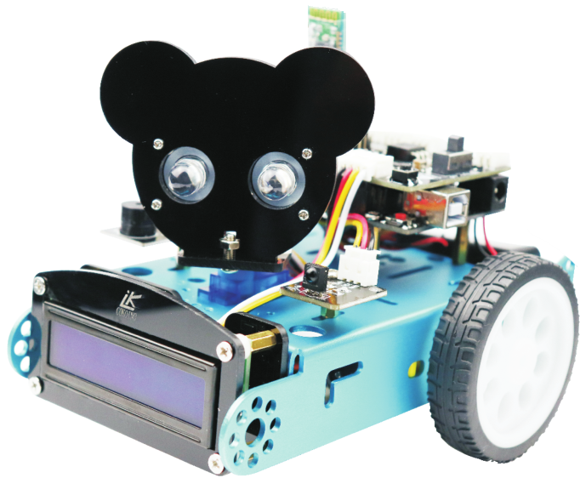
1.1About US
Xi'an Cokoino Intelligent Technology Co., Ltd. is a technology company dedicated to develop, manufacturer and export open source hardware and educational robots.
Our products are mainly designed for students, teachers, DIY enthusiasts, researchers, designers and those who want to learn programming and electronics; Our growing product catalog includes various of controllers, shields, sensors, actuators, educational robots, STEM educational learning kits, DIY electronic building blocks, etc.; All of the products are equipped with a comprehensive tutorial and software for beginners to get started.

1.2What is Arduino?
Arduino is an open-source electronics platform based on easy-to-use hardware and software. Arduino boards are able to read inputs - light on a sensor, a finger on a button, or a Twitter message - and turn it into an output - activating a motor, turning on an LED, publishing something online. You can tell your board what to do by sending a set of instructions to the microcontroller on the board. To do so you use the Arduino programming language (based on Wiring), and the Arduino Software (IDE), based on Processing.

Over the years Arduino has been the brain of thousands of projects, from everyday objects to complex scientific instruments. A worldwide community of makers - students, hobbyists, artists, programmers, and professionals - has gathered around this open-source platform, their contributions have added up to an incredible amount of accessible knowledge that can be of great help to novices and experts alike.

Arduino was born at the Ivrea Interaction Design Institute as an easy tool for fast prototyping, aimed at students without a background in electronics and programming. As soon as it reached a wider community, the Arduino board started changing to adapt to new needs and challenges, differentiating its offer from simple 8-bit boards to products for IoT applications, wearable, 3D printing, and embedded environments. All Arduino boards are completely open-source, empowering users to build them independently and eventually adapt them to their particular needs. The software, too, is open-source, and it is growing through the contributions of users worldwide.
Why Arduino?

Thanks to its simple and accessible user experience, Arduino has been used in thousands of different projects and applications. The Arduino software is easy-to-use for beginners, yet flexible enough for advanced users. It runs on Mac, Windows, and Linux. Teachers and students use it to build low cost scientific instruments, to prove chemistry and physics principles, or to get started with programming and robotics. Designers and architects build interactive prototypes, musicians and artists use it for installations and to experiment with new musical instruments. Makers, of course, use it to build many of the projects exhibited at the Maker Faire, for example. Arduino is a key tool to learn new things. Anyone - children, hobbyists, artists, programmers - can start tinkering just following the step by step instructions of a kit, or sharing ideas online with other members of the Arduino community.

Arduino office site：https://www.arduino.cc/

1.3 What is Mixly
In recent years, Maker Education has become more and more popular,
creative electronic education courses based on Arduino are gradually being promoted in primary and secondary schools. However, due to the limitations of its technical threshold, how to set up a creative electronic course is a huge challenge for teachers and students (If use Arduino achieves creativity, people needs to be programmed in C/C language, which is almost impossible for students of lower ages. ).
Maker Education needed better graphical programming tools, and Mixly came into being. Mixly, the Chinese name is Mi Siqi, the full name is Mixly_Arduino, is a graphical programming software developed by the team of Education Department, Beijing Normal University, China.

Its advantages are as follows:
- Mixly is completely green in design.-No complicated installation is required. After downloading the installation package, you can run it directly.No need to install additional browsers and Java runtime environment, it is very convenient to use.
- Mixly uses graphical blocks instead of complex text operations.-Children can program by dragging blocks directly while using Mixly. Different color graphical blocks represent different types of functional blocks that are easily distinguishable.
- Powerful-0.96 version of the Mi Siqi has realized all the functions of arduino, able to adapt to the various needs of teaching and competition. Currently, Mixly0.998 is the latest version.
- Mixly supports all official development boards of Arduino-Mixly will automatically change the pin number, interrupt number, analog output pin, etc. in the development board according to the type of development board; meanwhile, Mixly also supports third-party development boards.
- In order to achieve sustainable development, Mixly allows manufacturers to develop their own unique functional modules on mixly, which is the most important feature that Mixly distinguishes from other arduino graphical programming. For example, the Mixly software developed by Bear's Kids Square has added a unique PandaPaino module to achieve some creative features, for example, the fruit piano.
Office site of mixly：http://mixly.org/
Remarks:
Mixly's official website is a Chinese interface. You can install a Google browser and use it to translate into English. The IDE's programming interface language supports Chinese, English and Spanish.

1.3 About Bearbot Coding Kit
The Bearbot Coding Car Kit is a very interesting tool to learn robot platform, robot building, coding and electronic. Its structural design is very unique that the installation is very convenient, and its connecters are foolproof. It is based on the Arduino platform and supports mixly graphical programming. We sell not only products, but also knowledge. The Bearbot is versatile and cool, from learning each module to assembling and controlling the car, it makes learning electronics and programming is no longer a suffering, tedious and hard thing.

2.Introduction to Electronic Hardware
2.1 Introduction of COKOINO UNO R3 Board
2.2 Introduction of COKOINO Motor Drive Shield
2.3 Introduction of COKOINO Ultrasonic Sensor
2.4 Introduction of COKOINO IIC 1602LCD Display
2.5 Introduction of COKOINO HC-06 Bluetooth Module
2.6 Introduction of COKOINO 9G Servo
2.7 Introduction of COKOINO Three-way Module
2.8 Introduction of COKOINO Active Buzzer Module
2.9 Introduction of COKOINO IR Receiver Module
Note: The above information is stored in the "Separate Electronic Module" folder, please be sure to read it carefully.

3 How to use the software
3.1 Get the code
All the sample programs are stored in the "code" folder, which contains two different IDE programming codes, arduino and mixly.
3.2 Install Arduino IDE
Please refer to the CKD0001 Introduction of COKOINO UNO R3 Board, which contains detailed instructions on how to use Arduino. The "code"->"arduino IDE" folder provides the 1.8.5 version of the IED. The operation method is the same as that described in the manual.
3.3 Install mixly IDE
Please refer to the CKD0001 UNO R3 mixly tutorial, which has detailed instructions on how to use Mixly. The "code"->"mixly IDE" folder provides the 0.998 version of the IED.
3.4 Install Android Bluetooth APP
Cokoino Bluetooth APP is a mobile app that we specially developed for HC-06 communication, which is stored in the android APP folder.
Just copy the APP we provided to your Android phone, then click to install it, you will find it running as shown below:
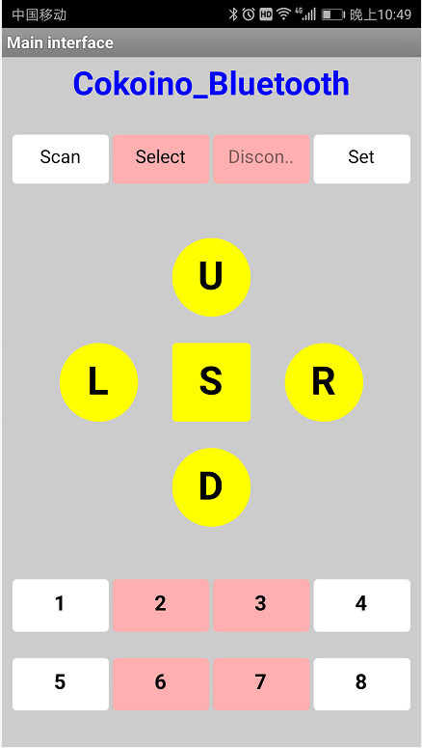
3.41 Connect Bluetooth to mobile phone
Click to open the bluetooth app on the phone, if your phone does not have Bluetooth enabled, the software will automatically prompt you to turn on Bluetooth.
If the Bluetooth of your phone is already turned on, click the "Scan" button to enter the Bluetooth pairing interface and select the Bluetooth you need to pair.
Take HC-06 as an example. After Bluetooth is powered on correctly, the pairing password is 0000 or 1234.
Then return to the main interface of the Bluetooth APP, click the Select button to enter the Bluetooth connection interface, select the Bluetooth you need to connect, it will automatically return to the main interface, the "Disconnect" tab will become Connect, indicating that Bluetooth is connected, The light of the HC-06 module will be on constantly (the bluetooth disconnected, the light on the module will flash), then the phone can communicate with HC-06 Bluetooth.

3.42 Disconnect Bluetooth
When Bluetooth is connected to the phone, if you want to disconnect it, please click the Connect tab, and the label will turn into a gray "Disconnect". If you want to pair again, click the Select button again and reconnect.

3.43 Set the data sent by APP
This app has 13 send buttons, each of which sends a variable value. Just click the Set button on the main interface to enter the parameter setting interface, as shown below.
Simply fill in the data you need to send at the corresponding button label, then return to the main interface and use it.
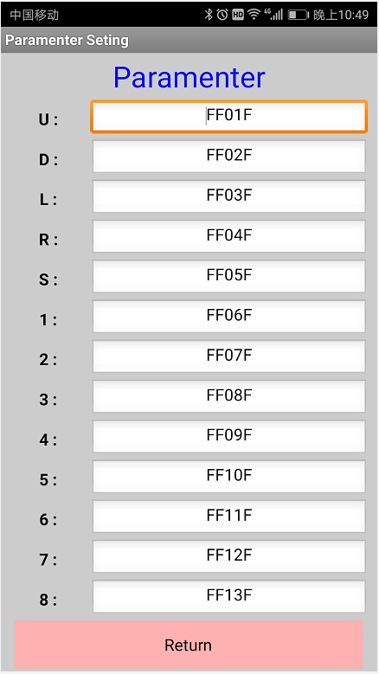
parameter setting interface

- Code for Bearbot Coding Kit

The sample code is stored in the "code"->"arduino_code" folder. Before compiling, please copy the library files in the "lib" folder of our tutorial to the "libraries" folder in the Arduino IDE installation directory. As shown below: 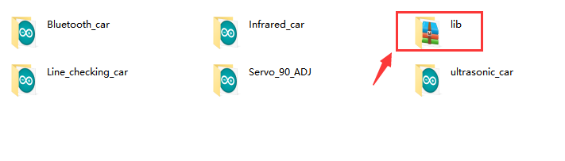
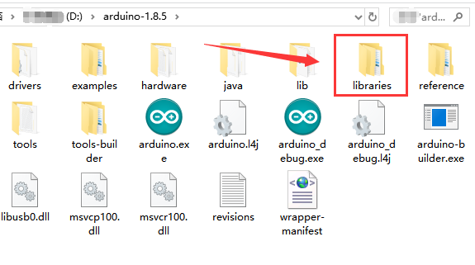
4.1 Code to adjust the angle of the Servo
The servo motor can rotate 360 degrees when it is not working. It is difficult to find the angle we need. Therefore, the servo motor needs to be adjusted at 90 degrees with this program during assembly. The operation is as follows:
1. Upload the Servo_90_ADJ program to the UNO R3 motherboard.
2. Insert the motor drive board directly into the UNO R3 main board.
3. Connect the servo motor to the D11 position of the motor drive board. The brown wire of the servo motor is connected to G, and the red line is connected to V.
The yellow line is connected to S.
4. You need to install two 18650 lithium batteries in the battery box, then connect it to the power interface of the motor driver board, then turn on the power switch.
When assembling the Bearbot head in the future, you need to pay attention to the installation direction of the servo. As shown below:
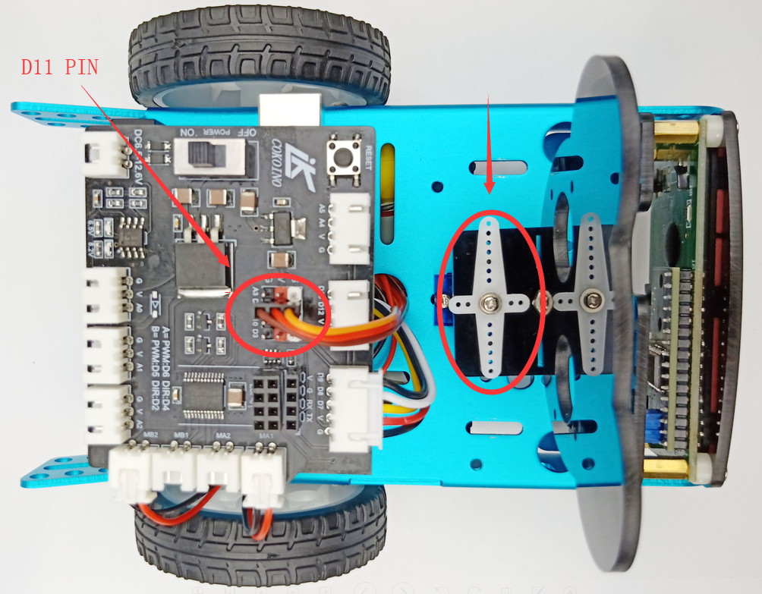
4.2 Code for Bluetooth control（Bluetooth_car）
This is the arduino code of the Bluetooth remote control car. Note: When uploading the code, the HC-06 Bluetooth module cannot be plugged into the expansion board.
So, after install the Cokoino Bluetooth APP on the Android phone, open the "Bluetooth_car" code with the arduino IDE, then connect the car's uno R3 motherboard to computer via the USB cable.
Upload the code to the UNO R3 motherboard, then plug the HC-06 Bluetooth back to the car, install the 18650 batteries in the battery case and turn on its power switch to power the car.

Open the Cokoino Bluetooth APP, and then click the “Set” button to enter the parameter setting interface, as shown below:
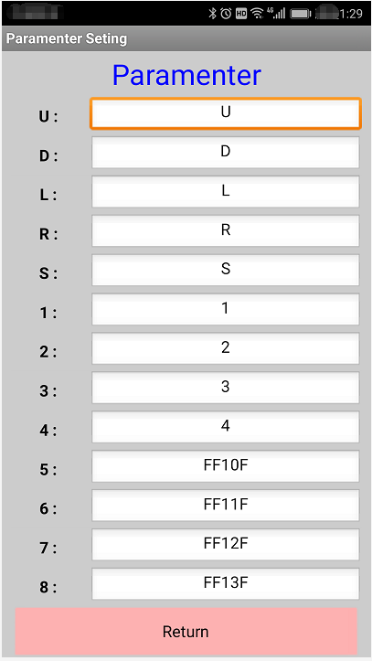
Then return to the APP main interface, search HC-06 Bluetooth to connect the phone to the HC-06 Bluetooth module, you will find that the LED light on the Bluetooth module is steady (it is shiny when Bluetooth is not connected to the phone).
Then you can control the car through the following buttons on the main interface:
U key: forward
D button: back
L key: car turn the car left
R button: turn the car right
S key: stop
1 button: On/Off active buzzer
2 button: Turn the car's head to the left
3 button: Turn the car's head to the right
4 button: On / off RGB lights4.3 Infrared_car

4.3 Code for Infrared control（Infrared_car）
Upload the "Infrared_car" code to the UNO R3 motherboard via the arduino IDE. You can control the action of the car via the infrared remote control. 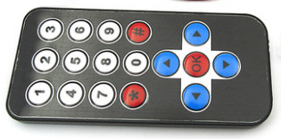
The function of the infrared remote control is as follows：
：Car go forward ：Car go back ：Car turn left ：Car turn right ：On/off active buzzer ：On/off RGB light module ：Turn the car's head to the left ：Turn the car's head to the right

4.4 Code for Ultrasonic Monitoring (ultrasonic_car)
Upload the ultrasonic_car code to the UNO R3 motherboard via the arduino IDE, then place the car on the ground, turn on the power switch, and the car will automatically run and avoid obstacles in front. The principle is that the ultrasonic sensor of the head of the car detects the obstacle in front and stops moving forward, and then turns the head through the servo motor to detect whether there are obstacles on the left and right, and then advances in the direction of no obstacle. If there are obstacles on the front and left and right sides, the car will retreat.

4.5 Code for Line_tracking_car
Make a black line with a width of about 1 cm on white paper or on the surface of a white object.
Upload the Line_tracking_car code to the UNO R3 motherboard via the arduino IDE.
Place the bearbot car on the ground and point the line-tracking sensor of the car to the black line.
Turn on the power switch and the car will automatically run around the black circle.
The principle is that the infrared rays emitted by the line-tracking sensor are easily reflected by white objects and are easily absorbed by black objects.
If the module detects that the infrared light is reflected, it will output a low level. The module detects that the infrared light is absorbed, it will output a high level. The two signals are used to adjust the direction of the car so that the car does not deviate from the black line.

- Mixly Code for Bearbot Coding Kit
The detailed tutorial is placed in "Single Board Data" -> "CKD0001 UNO R3" -> "CKD0001 UNO R3 mixly Getting Started Tutorial". When the learning is completed, please burn the code in the package "code"->"mixly_code" folder to UNO R3.

5.1 Servo_90_ADJ
The servo motor can rotate 360 degrees when it is not working. It is difficult to find the angle we need. Therefore, the servo motor needs to be adjusted at 90 degrees with this program during assembly. The operation is as follows:
1. Upload the Servo_90_ADJ program to the UNO R3 motherboard.
2. Insert the motor drive board directly into the UNO R3 main board.
3. Connect the servo motor to the D11 position of the motor drive board. The brown wire of the servo motor is connected to G, and the red line is connected to V.
The yellow line is connected to S.
4. You need to install two 18650 lithium batteries in the battery box, then connect it to the power interface of the motor driver board, then turn on the power switch.
When assembling the Bearbot head in the future, you need to pay attention to the installation direction of the servo. As shown below:
5.2 Bluetooth_car
This is the mixly code of the Bluetooth remote control car. Install the Cokoino Bluetooth APP on the Android phone, unplug the HC-06 Bluetooth from the installed car, upload the Bluetooth_car program to the uno r3 controller with the mixedly IDE, then plug the HC-06 Bluetooth module back into the car, install the 18650 battery, and turn on the power switch.
Open the Cokoino Bluetooth APP, and then click the “Set” button to enter the parameter setting interface, as shown below:
Then return to the APP main interface, search HC-06 Bluetooth to connect the phone to the HC-06 Bluetooth module, you will find that the LED light on the Bluetooth module is steady (it is shiny when Bluetooth is not connected to the phone).
Then you can control the car through the following buttons on the main interface:
U key: forward
D button: back
L key: car turn the car left
R button: turn the car right
S key: stop
1 button: On/Off active buzzer
2 button: Turn the car's head to the left
3 button: Turn the car's head to the right
4 button: On / off RGB lights4.3 Infrared_car

5.3 Infrared_car
Upload the "Infrared_car" code to the UNO R3 motherboard via the Mixly IDE. You can control the action of the car via the infrared remote control.
The function of the infrared remote control is as follows：
：Car go forward ：Car go back ：Car turn left ：Car turn right ：On/off active buzzer ：On/off RG

5.4 ultrasonic_car
Upload the ultrasonic_car code to the UNO R3 motherboard via the mixly IDE, then place the car on the ground, turn on the power switch, and the car will automatically run and avoid obstacles in front. The principle is that the ultrasonic sensor of the head of the car detects the obstacle in front and stops moving forward, and then turns the head through the servo motor to detect whether there are obstacles on the left and right, and then advances in the direction of no obstacle. If there are obstacles on the front and left and right sides, the car will retreat.

5.5 Line_checking_car
Make a black line with a width of about 1 cm on white paper or on the surface of a white object.
Upload the Line_tracking_car code to the UNO R3 motherboard via the mixly IDE.
Place the bearbot car on the ground and point the line-tracking sensor of the car to the black line.
Turn on the power switch and the car will automatically run around the black circle.
The principle is that the infrared rays emitted by the line-tracking sensor are easily reflected by white objects and are easily absorbed by black objects.
If the module detects that the infrared light is reflected, it will output a low level. The module detects that the infrared light is absorbed, it will output a high level. The two signals are used to adjust the direction of the car so that the car does not deviate from the black line.

